Project Report on

“Hotel Management System”

*in partial fulfilment for the award of the degree*

of

**BACHELOR OF TECHNOLOGY**

**DEPARTMENT OF COMPUTER SCIENCE AND ENGINEERING**

Lovely professional University

Phagwara, jalandhar

**Submitted By:**

Name Ritesh kumar Reg no 12018588

**College Name**

**DECLARATION**

I declare that project entitled **“Hotel Management System”** is my own work conducted under the supervision of **“Professor Name”**, Department of **Branch Name**, **College Name**, **College Address**

I further declare that, to the best of my knowledge the project does not contain any work which has been submitted for the award of the degree either in the University or in any other University/Deemed University without proper citations.

**Acknowledgment**

I wish to express my sincere gratitude to God for his protection, providence, guidance and above all, for sustaining us.

I would like to express our special thanks of gratitude to our professor ‘**Professor Name**’ as well as our H.O.D ‘**HOD Name**’ who gave me the golden opportunity to do this wonderful **project** on the topic **‘Hotel Management System’** , which also helped me in doing a lot of Research and gaining some precious

**Abstract**

In my project “**Hotel Management System**” I have tried to show how the data/information in hotels is managed. This is just an overview of management in hotels. It manages and maintains the records of customers, rooms, employees and drivers in the hotel. The project is aimed to maintain the day-to-day state of admission/vacation of Residents, List of employees, room details etc. Main objective of this project is to provide solution for hotel to manage most there work using computerized process. This software application will help admin to handle customer information, room allocation details, Payment details etc.

The rooms have different categories like single bed, double bed etc. so their charges and records will be maintained accordingly.

This software has been made in a user friendly interface, so that anyone can add, delete, update the entries and handle all the transactions easily. As a security I have provided Admin username and Password.

**Introduction**

The project, Hotel Management System is a desktop-based application that allows the hotel manager to handle all hotel activities online. Interactive GUI and the ability to manage various rooms, employees, drivers and customers make this system very flexible and convenient. The hotel manager is a very busy person and does not have the time to sit and manage the entire activities manually on paper. This application gives him the power and flexibility to manage the entire system from a single online system. Hotel management project provides room booking, staff management and other necessary hotel management features. The system allows the manager to post available rooms in the system.

The Purpose of the whole process is to ease the daily or regular activities of the Hotel Management into an automatic computerized retrievable process. The daily activities includes the Room activities, Entering details of the new customer check in, To allocate a room as per the customer need and interest, Recording the checkout time and details, Releasing or Empty of room and to record the process in a computer system for future.

The application of the Hotel Management System bears the following functions to use by the Administrator:

* Add a new Room
* Add an Employee
* Add a new Customer
* Check room status
* Check all employees’ details
* Check all Customers’ details
* Update room status
* Update check status etc.

**Administrative Modules**

There are 2 modules I have included in this project :

1. Admin : Admin can add a new room , a new employee and a new driver.
2. Receptionist : Receptionist can add a new customer and allocate rooms, can check all room details, customers details, employee details, search for a particular room etc.

**Main Objective**

Main objective of this project is to provide solution for hotel to manage most there work using computerized process. This software application will help admin to handle customer information, room allocation details, Payment details etc.

* Keeping records of admission of customers.
* Facilities provided by Hotel are fully utilized in effective and efficient manner.

**Existing System:**

In the existing manual system a lot of time is spent in communicating the information across different branches. There is a need for an automated system, which has some centralized control over the entire process. Conventional System makes use of huge amounts of paper for recording transactions. All the Hotel records are to be maintained for the details of each customer, Fee details, Room Allocation etc.

**Disadvantages:**

* Time consuming
* Inaccuracy of data

**Proposed System:**

Proposed system is the computerized version of the existing system which provides easy and quick access over the data. Keeping the records of admission of Resident properly so that facilities provided by Hotels are fully utilized in effective and efficient manner.

**Advantages:**

* Less Time consuming
* Maintain accuracy

**Requirements**

**User Interface:**

The User interface required to be developed for the system should be user friendly and attractive.

There are two sets of java APIs for graphics programming:

AWT (Abstract Windowing Toolkit) and Swing.

* AWT API was introduced in JDK 1.0. Most of the AWT components have become obsolete and should be replaced by newer Swing components.
* Swing API, a much more comprehensive set of graphics libraries that enhances the AWT, was introduced as part of Java Foundation Classes (JFC) after the release of JDK 1.1. JFC consists of Swing, Java2D, Accessibility, Internationalization, and Pluggable Look-and-Feel Support APIs. JFC was an add-on to JDK 1.1 but has been integrated into core Java since JDK 1.2.

**Software Interfaces**

Programming Language Java

Back End Tool MySql 5.5 command line client

**Database Tables**

1. Customer

|  |  |  |
| --- | --- | --- |
| **Field** | **Datatype** | **Constraint** |
| id | Varchar(30) | NN |
| number | Numeric(30) | PK |
| name | Varchar(30) | NN |
| gender | Varchar(30) | NN |
| country | Varchar(30) | NN |
| Room number | Numeric(30) | NN |
| Status | Varchar(30) | NN |
| Deposit | Numeric(30) | NN |

1. Room

|  |  |  |
| --- | --- | --- |
| **Field** | **Datatype** | **Constraint** |
| Room_number | Numeric(30) | PK |
| availability | Varchar(30) | NN |
| Clean status | Varchar(30) | NN |
| Price | Number(30) | NN |
| BedType | Varchar(30) | NN |

3.Employee

|  |  |  |
| --- | --- | --- |
| **Field** | **DataType** | **Constraint** |
| Name | Varchar(30) | NN |
| Age | Numeric(30) | NN |
| Gender | Varchar(30) | NN |
| Job | Varchar(30) | NN |
| Salary | Number(30) | NN |
| Phone | Number(30) | NN |
| Adhar | Number(30) | PK |
| Email | Varchar(30) | NN |

4.Driver

|  |  |  |
| --- | --- | --- |
| **Field** | **DataType** | **Constraint** |
| Name | Varchar(30) | NN |
| Age | Numeric(30) | NN |
| Gender | Varchar(30) | NN |
| Company | Varchar(30) | NN |
| Brand | Varchar(30) | NN |
| Available | Varchar(30) | NN |
| Location | Varchar(30) | NN |

5.Login

|  |  |  |
| --- | --- | --- |
| **Field** | **DataType** | **Constraint** |
| Username | Varchar(30) | PK |
| Password | Varchar(30) | NN |

6.Department

|  |  |  |
| --- | --- | --- |
| **Field** | **DataType** | **Constraint** |
| Department | Varchar(30) | PK |
| Budget | Numeric(30) | NN |

**Screenshots**

1. 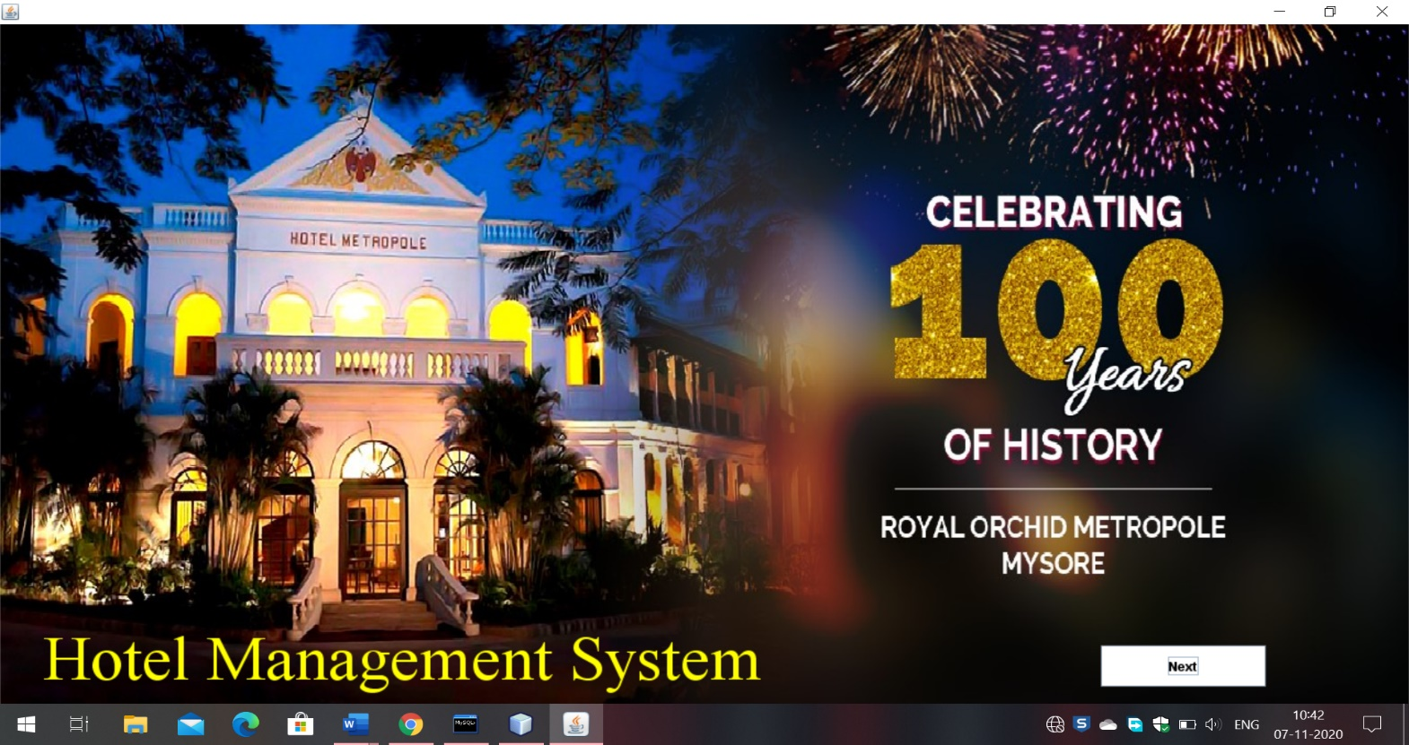Start Screen

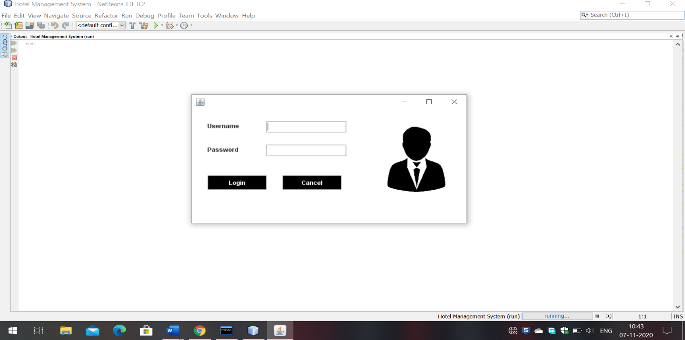2.Login Page

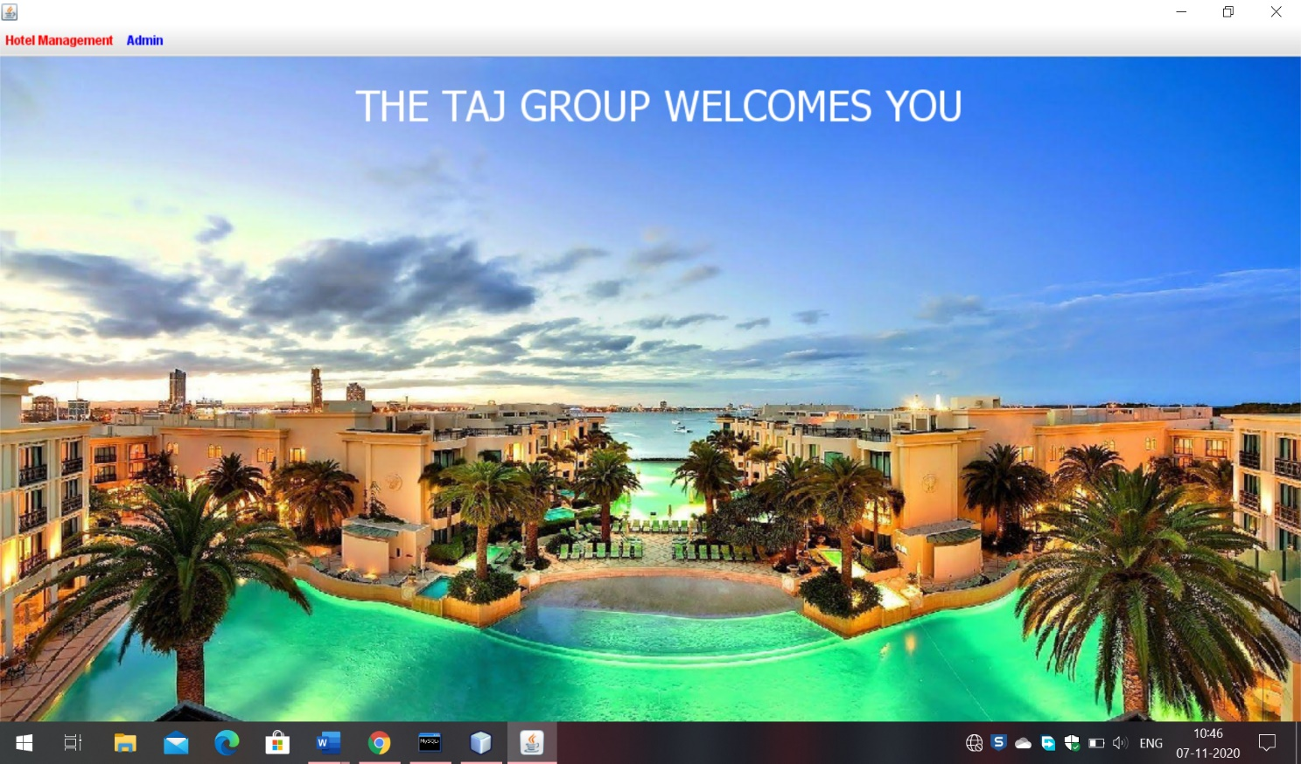3.DashBoard Page

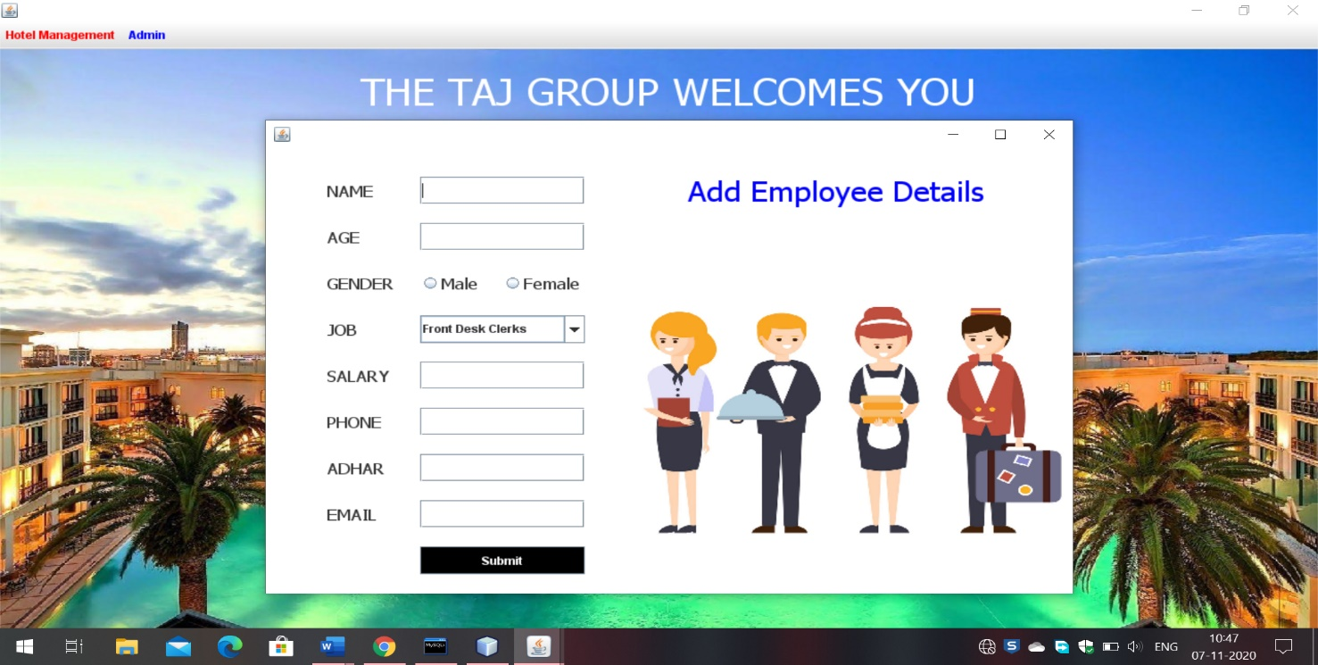4.Add Employee

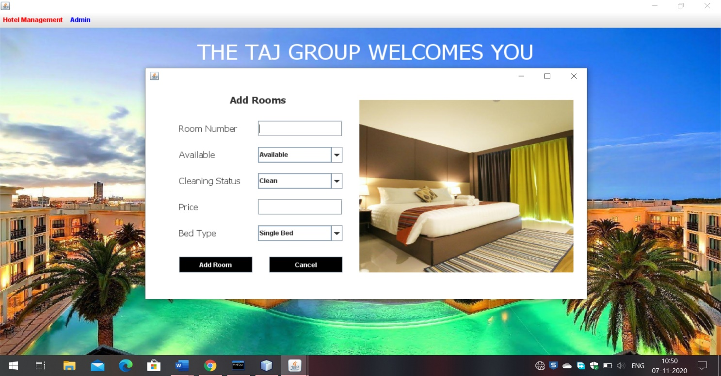5.Add Rooms

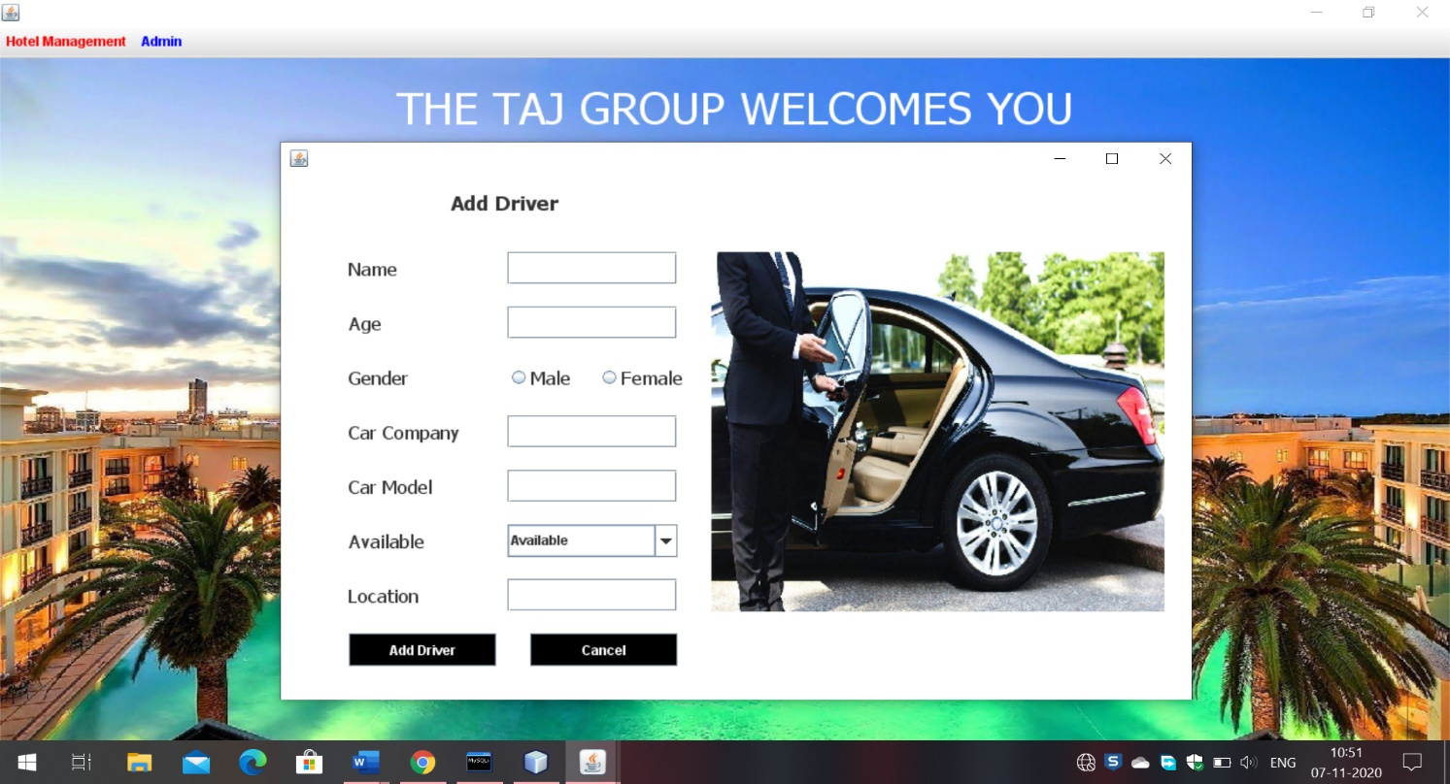6.Add Driver

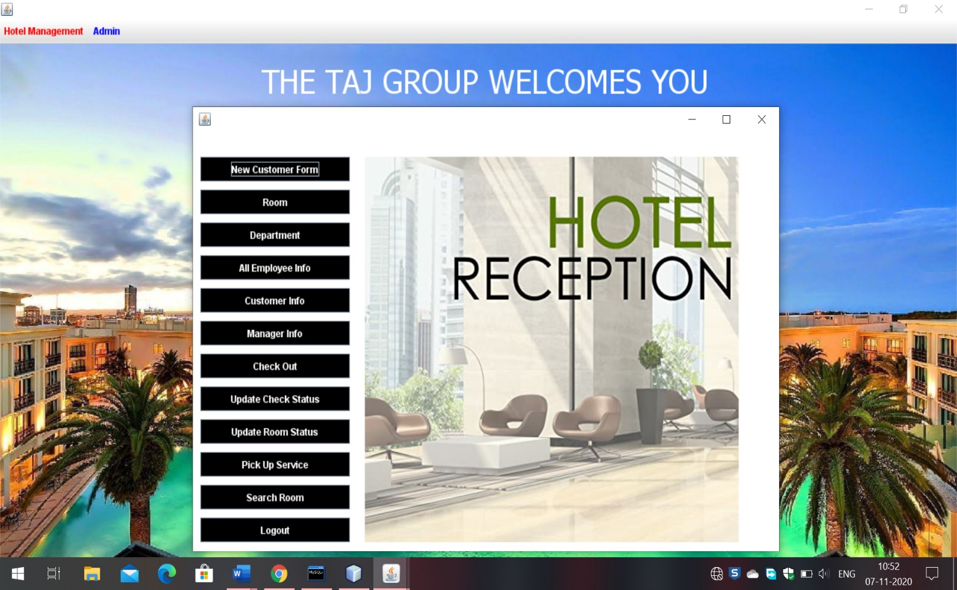7.Reception

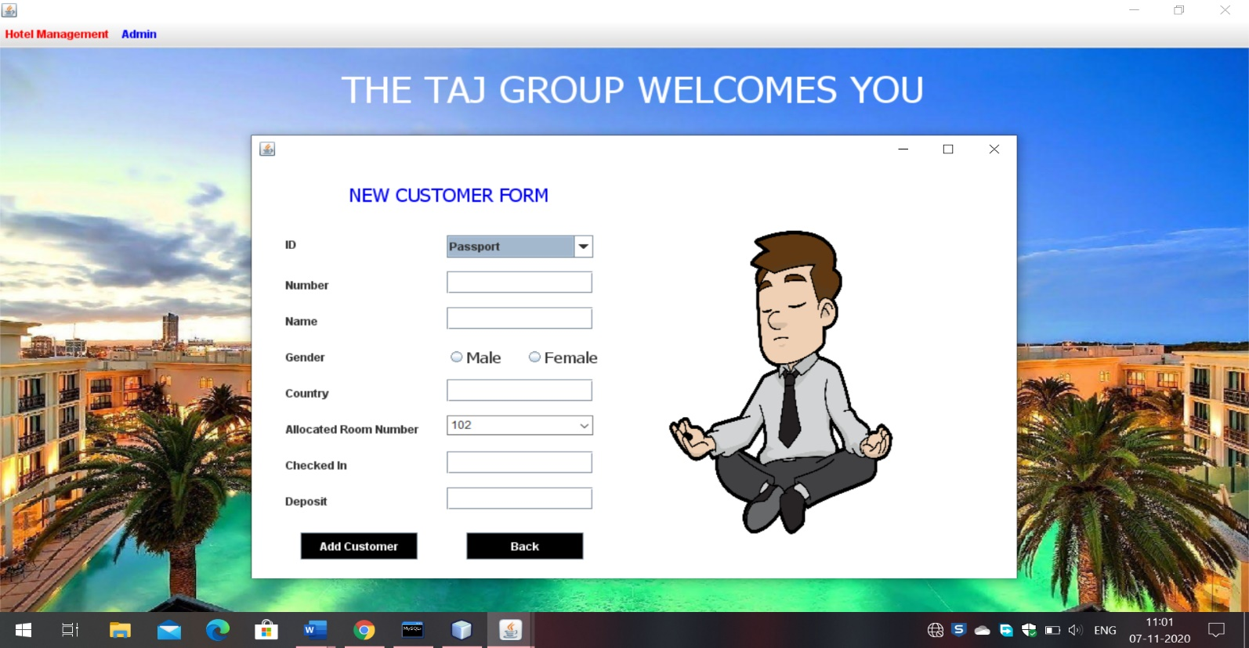8.Add new Customer

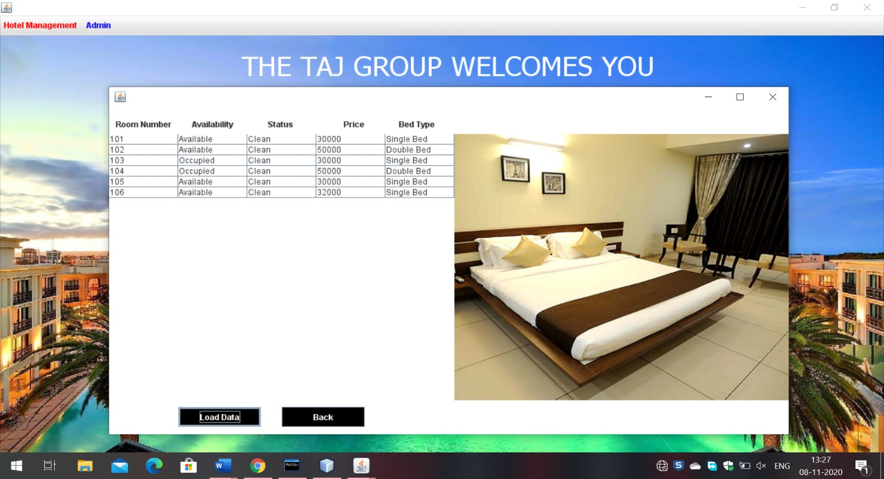 9.Room Details

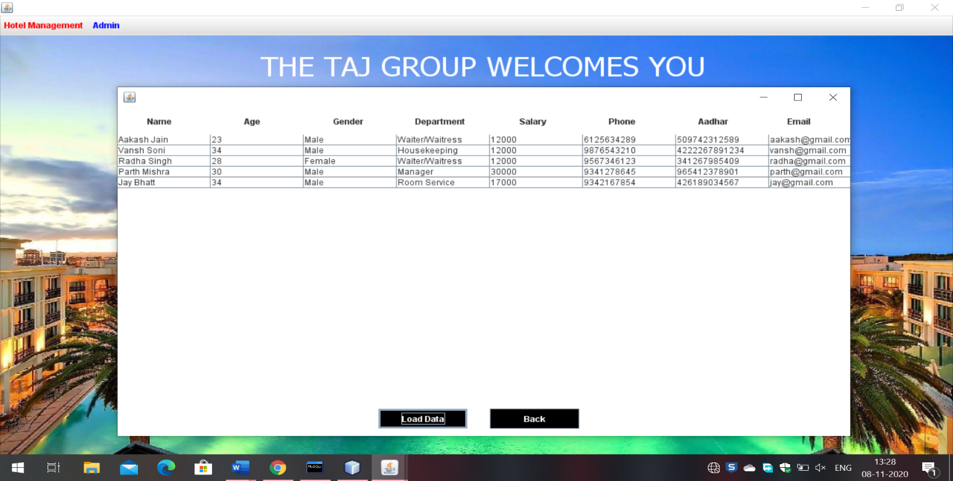10.Employee Details

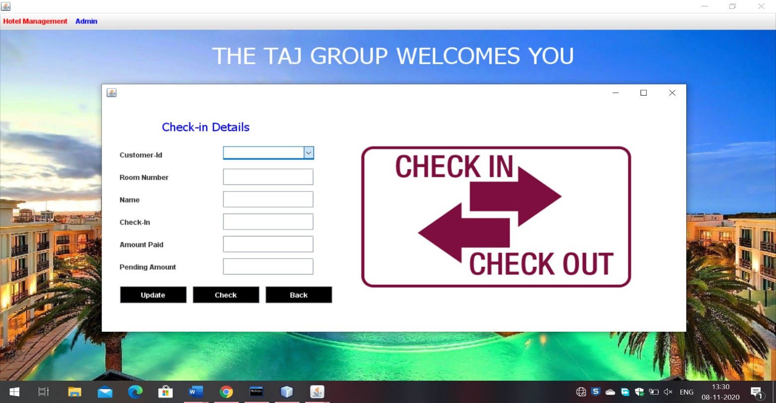11. Check In Details

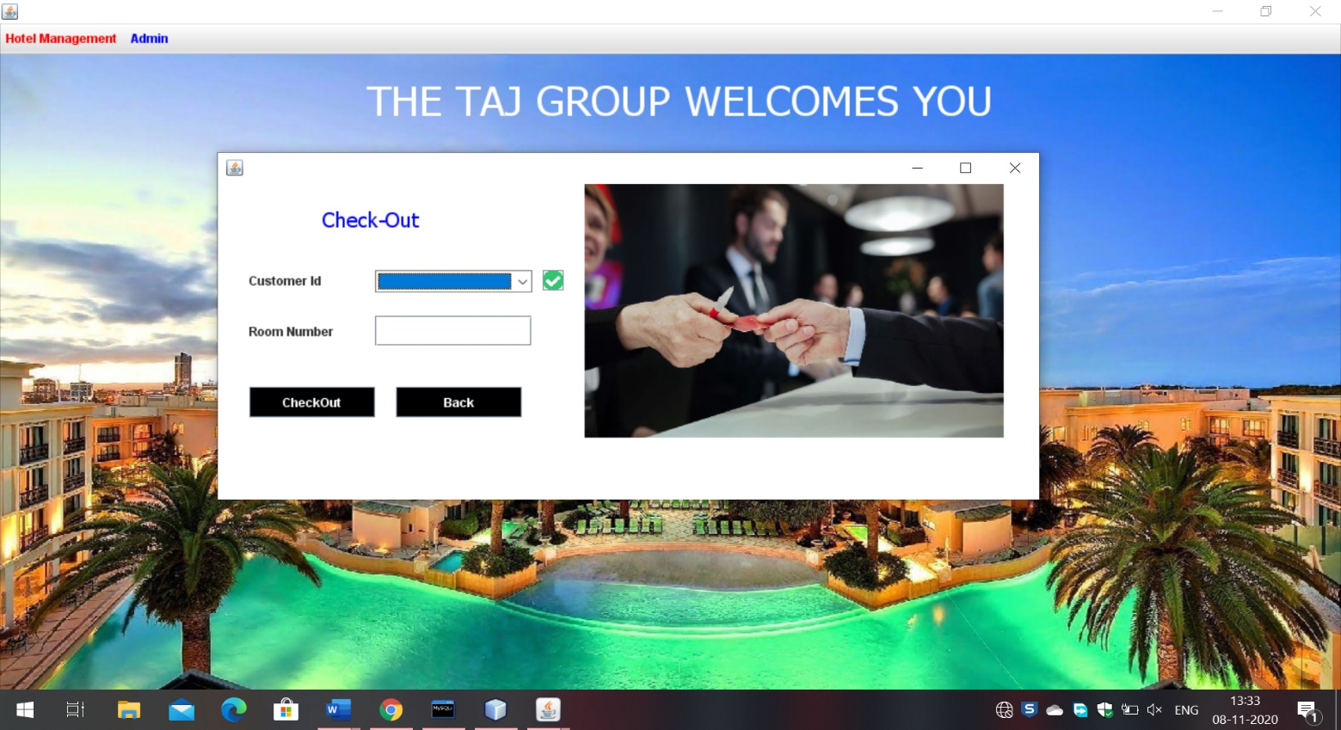12. Check out

**Conclusion**

In this project I have tried my best to make user friendly software. This software can be handled by any person who has little bit of idea of computers. In this software I have tried to meet most of the requirements of the present hotel management system including maintaining details of customers, rooms, employees and drivers. I also keep provision to update the details of customers, rooms and employees. In my effort I have tried to make my software all the more user friendly but there may some features which I would like to include in my continuous attempts.